SEC Form 3
FORM 3 | UNITED STATES SECURITIES AND EXCHANGE COMMISSION
 | Washington, D.C. 20549
 | Washington, D.C. 20549 |  | OMB APPROVAL
 | INITIAL STATEMENT OF BENEFICIAL OWNERSHIP OF SECURITIES
 | INITIAL STATEMENT OF BENEFICIAL OWNERSHIP OF SECURITIES |  | OMB Number: | 3235-0104
 |  |  | Estimated average burden
 | Filed pursuant to Section 16(a) of the Securities Exchange Act of 1934 |  | hours per response: | 0.5
or Section 30(h) of the Investment Company Act of 1940
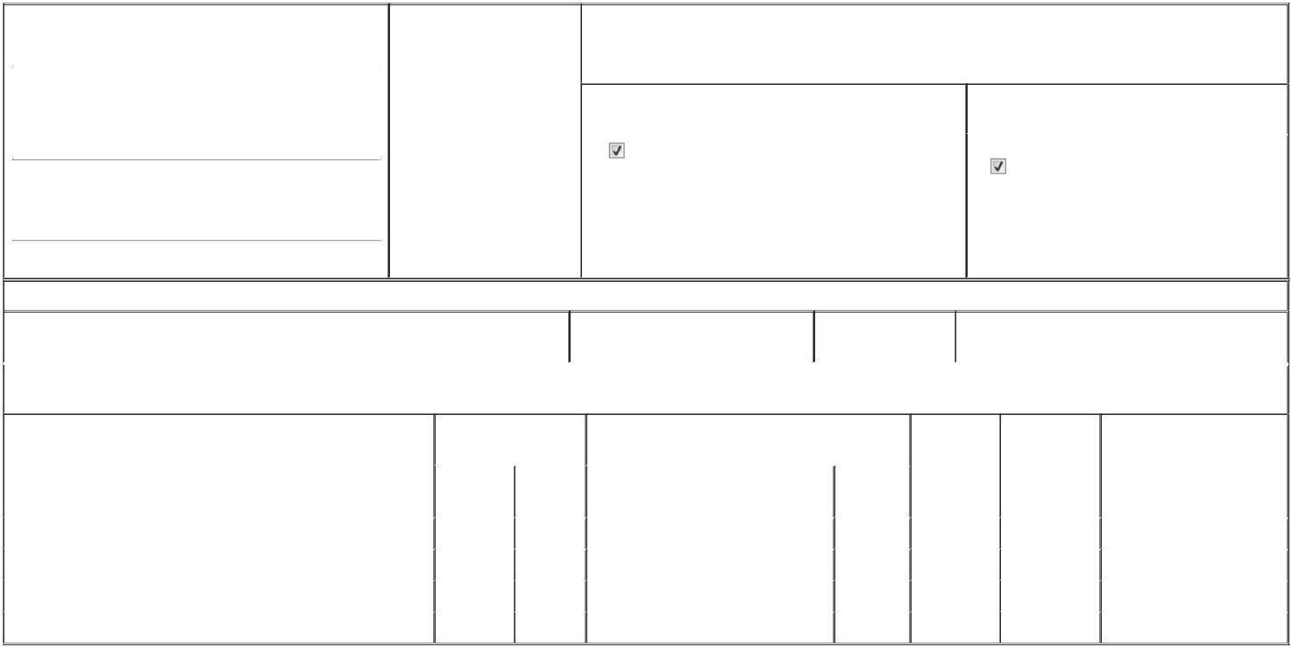

1. Name and Address of Reporting Person* |  |  |  |  |  | 2. Date of Event Requiring
 |  | Thrash Trent Pollard |  |  |  | Statement (Month/Day/Year)
 |  |  |  |  | 03/31/2026
 |  | (Last) | (First) |  | (Middle)

C/O TASKUS, INC.

1650 INDEPENDENCE DRIVE, SUITE 100

(Street)
^{NEW} TX 78132

BRAUNFELS

3. Issuer Name and Ticker or Trading Symbol

TaskUs, Inc. [ TASK ]

4. Relationship of Reporting Person(s) to Issuer |  | 5. | If Amendment, Date of Original Filed (Month/Day/Year)
(Check all applicable)
Director | 10% Owner
Officer (give title | Other (specify below) | 6. | Individual or Joint/Group Filing (Check Applicable Line)
below) |  |  | Form filed by One Reporting Person

Interim CFO | Form filed by More than One Reporting Person

(City) (State) (Zip)

Table I - Non-Derivative Securities Beneficially Owned

 | 1. Title of Security (Instr. 4) | 2. Amount of Securities Beneficially | 3. Ownership Form: | 4. Nature of Indirect Beneficial Ownership (Instr. 5)
 |  | Owned (Instr. 4) | Direct (D) or Indirect
 |  |  | (I) (Instr. 5)

Table II - Derivative Securities Beneficially Owned

(e.g., puts, calls, warrants, options, convertible securities)

1. Title of Derivative Security (Instr. 4) | 2. Date Exercisable and |  | 3. Title and Amount of Securities Underlying |  | 4. | 5. Ownership | 6. Nature of Indirect Beneficial
 | Expiration Date |  | Derivative Security (Instr. 4) |  | Conversion | Form: Direct | Ownership (Instr. 5)
 | (Month/Day/Year) |  |  |  | or Exercise | (D) or Indirect
 |  |  |  |  | Price of | (I) (Instr. 5)
 |  |  |  | Amount or | Price of | (I) (Instr. 5)
 |  |  |  | Amount or | Derivative
 | Date | Expiration | Title | Number of | Security
 | Exercisable | Date | Title | Shares
Restricted Stock Units | (1) | (1) | Class A Common Stock | 20,618 | (1) | D
Restricted Stock Units | (2) | (2) | Class A Common Stock | 6,942 | (2) | D
Restricted Stock Units | (3) | (3) | Class A Common Stock | 10,969 | (3) | D
Stock Options (right to buy) | (4) | 09/30/2031 | Class A Common Stock | 12,430 | 62.72⁽⁵⁾ | D

Explanation of Responses:

- Each restricted stock unit ("RSU") represents a contingent right to receive one share of Class A common stock of the Issuer. The RSUs will be settled in either Class A common stock of the Issuer or cash (or a combination thereof). These RSUs vest annually over three years as follows: 33% on March 9, 2027; 33% on March 9, 2028; and 34% on March 9, 2029.

- Each restricted stock unit ("RSU") represents a contingent right to receive one share of Class A common stock of the Issuer. The RSUs will be settled in either Class A common stock of the Issuer or cash (or a combination thereof). These RSUs vest annually over three years as follows: 33% on March 15, 2025; 33% on March 15, 2026; and 34% on March 15, 2027.

- Each restricted stock unit ("RSU") represents a contingent right to receive one share of Class A common stock of the Issuer. The RSUs will be settled in either Class A common stock of the Issuer or cash (or a combination thereof). These RSUs vest annually over three years as follows: 33% on March 7, 2026; 33% on March 7, 2027; and 34% on March 7, 2028.

- These stock options are fully vested and exercisable.

- In connection with the special cash dividend of $3.65 per share, paid on March 25, 2026, the strike price was reduced by $3.65 from $66.37.

Remarks:

Exhibit 24 - Power of Attorney

/s/ Jody M. Stanley, as Attorney-in-fact 04/08/2026

** Signature of Reporting Person Date

Reminder: Report on a separate line for each class of securities beneficially owned directly or indirectly.

* If the form is filed by more than one reporting person, see Instruction 5 (b)(v).

- Intentional misstatements or omissions of facts constitute Federal Criminal Violations See 18 U.S.C. 1001 and 15 U.S.C. 78ff(a). Note: File three copies of this Form, one of which must be manually signed. If space is insufficient, see Instruction 6 for procedure.
Persons who respond to the collection of information contained in this form are not required to respond unless the form displays a currently valid OMB Number.



